# Table of Contents

Table of Contents 1

Hamilton Warehouse Dispatch Manual 2

1. Understanding Phoenix (ERP) 2

1.1. Handheld Device UI 2

1.2. "Picks" Screen - Order Details and Merging 4

1.3. Opening an Order - The Picking Screen and Scanning Process 5

1.4. Alternate Locations and Page Navigation (Within Picking Screen) 9

2. Order Picking Procedures 10

2.1. Best Practices for Picking Orders 10

2.2. Warehouse Layout and Picking Order 11

2.3. Underpicking an Order 12

3. Packing Procedures 13

3.1. General Packing Rules (Applies to all order types unless specified otherwise) 13

3.2. Carton Sizes and Volumes 14

3.3. "Packs" Menu Item 14

3.3.1. "Packs" Screen - Page 1: Consignment Details 15

3.3.2. "Packs" Screen - Page 2: Notes and Order Numbers 15

3.3.3. "Packs" Screen - Page 3: Carton Select Page 16

3.3.4. "Packs" Screen - Page 4: Packed Lines Overview 17

3.3.5. Finalizing the Pack - Bottom Screen Buttons 17

4. Order Types and Specific Procedures 18

4.1. NZC (New Zealand Couriers) Orders 18

4.1.1. General NZC Requirements 18

4.1.2. Dangerous Goods (DG) for NZC 19

4.1.3. Chilled Items for NZC 20

4.1.4. Carton Sizes for NZC 21

4.2. SVS Van Delivery Orders 21

4.2.1. General SVS Van Requirements 21

4.2.2. Chilled Items for SVS Vans 21

4.2.3. Carton Sizes and Van Routes 21

4.2.4. Van Loading Procedures 22

4.3. EDI / Toll Orders (Electronic Data Interchange) 22

4.3.1. EDI Order Types 22

4.3.2. Customer-Specific EDI Guidelines 23

Animates 23

Pet Stock 23

Pet.co 23

Pet Direct 24

4.4. Toll / TGE (Team Global Express) Orders (Palletized) 24

4.4.1. General Toll/TGE Guidelines 24

4.4.2. Using the Toll Carrier in Phoenix 24

4.4.3. Dangerous Goods (DG) for Toll/TGE 25

4.5. Dropships 25

5. Stock Count 25

# Hamilton Warehouse Dispatch Manual

## 1. Understanding Phoenix (ERP)

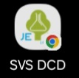**Phoenix** is our Enterprise Resource Planning (ERP) system. It's the central hub for managing all aspects of order processing, from picking to packing, and dispatch. You'll use Phoenix to view orders, record picking details, and generate necessary documentation.

### 1.1. Handheld Device UI

Your handheld device is your primary tool for interacting with Phoenix on the warehouse floor. Here's a breakdown of what you'll see:

**Main Menu Options:**

* 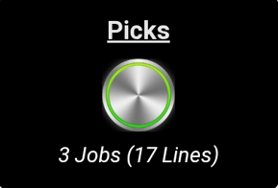**Picks:** This is where you'll spend most of your time, managing and executing all allocated picking tasks.
  + **Note:** The "Picks" menu item will only appear if a supervisor has assigned jobs to you.
  + **Overview:** When you have allocated jobs, the "Picks" screen will display:
    - **Jobs:** The total number of individual orders assigned to you.
    - **Lines:** The total number of *different* products across all your assigned orders. This is the count of unique items, regardless of their quantity. For example, if you have 3 orders and each order has 5 different products, the "Lines" count would be 15.
* **Packs:** This section is for processing and finalizing orders once picking is complete (details in Section 3).
* **Stock Count:** (TBD)
* **Send Photo:** This function isn't typically used by general warehouse staff.
* **Item Search:** Allows you to quickly look up basic information about a product.

**Bottom Bar Functions:**

* **Refresh:** Tap this to update the current screen with the latest data from Phoenix.
* **Product Info:** This offers a more detailed version of the 'Item Search' function, providing comprehensive product details.
* **Logout:** Always remember to log out safely when you're finished using the device.

### 1.2. "Picks" Screen - Order Details and Merging

When you select the "Picks" menu, you'll see a list of all jobs (orders) assigned to you. Each order section will display the following information:

* **Clinic Name:** The name of the clinic or customer for the order.
* **Clinic Address:** The delivery address for the order.
* **Dispatch Notes:** Any special instructions or notes related to the order.
* **Time Allocated:** How long ago the order was assigned to you for picking.
* **Lines:** The number of different products in the order.
* **Items:** The total number of *individual items* to be picked for the order. This is the sum of the quantities of all products. For example:
  + 1 Line, 20 Items: This means 1 product with a quantity of 20.
  + 2 Lines, 50 Items: This could be any combination (e.g., one product needing 1, the other needing 49; or each product needing 25). You'll need to open the order to see the exact quantities.
* A screenshot of a computer

  AI-generated content may be incorrect.**Special Item Icons:** Visual indicators for items with special handling requirements:
  + **Blue Shield:** Chilled items.
  + **Exclamation Point (!):** Dangerous Goods (DG).
  + **Snowflake:** Frozen goods.
  + **Yellow Tag:** Controlled substances.
  + **Stethoscope:** Equipment.

**Merging Orders:**

Next to each order section, you'll see a **"Click to merge"** button. This feature is designed to combine multiple orders for the *same clinic* into a single consignment, streamlining the packing and dispatch process.

* **How to Merge:**
  1. 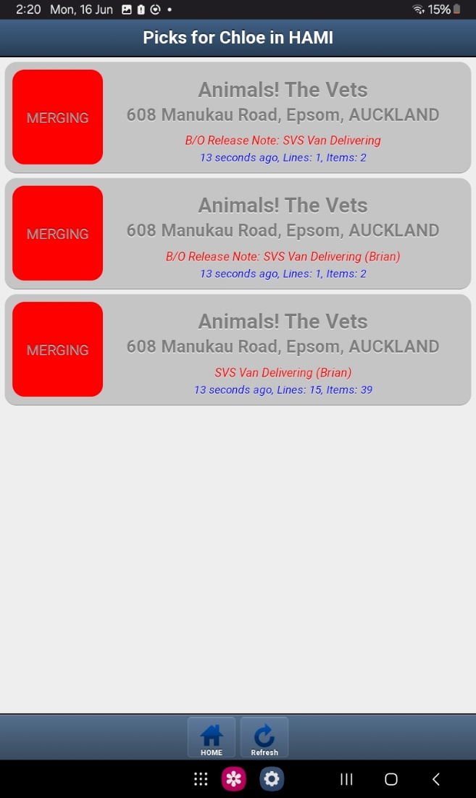Select the "Click to merge" button for all the orders belonging to the same clinic that you wish to combine.
  2. Once selected, click on any of the now-merged orders to open them all together for picking.
* **Important Considerations for Merging:**
  1. **Non-Mergeable Clinics:** Be aware that **certain clinics' orders are explicitly not to be merged**. This will be communicated (TBD) and should be strictly adhered to.
  2. **Address Variations:** Occasionally, Phoenix may prevent merging orders for the same clinic due to minor variations in the address, or even no visible change. If this occurs, you should still **send these orders together** in the same consignment, even if the system doesn't allow a digital merge.
  3. **Different Clinics:** You **cannot merge orders for different clinics**. The system is designed to prevent this, so you don't need to worry about accidentally combining unrelated orders.

### 1.3. Opening an Order - The Picking Screen and Scanning Process

Once you open an order from the "Picks" menu, the screen will guide you through picking each item. The information will be presented as follows, from top to bottom:

* **Location Instruction (Centered):** At the very top, Phoenix will instruct you on where to go: "Please go to either **Primary Location** or **Secondary Location**" (the specific location displayed depends on current stock levels and picking logic).
* 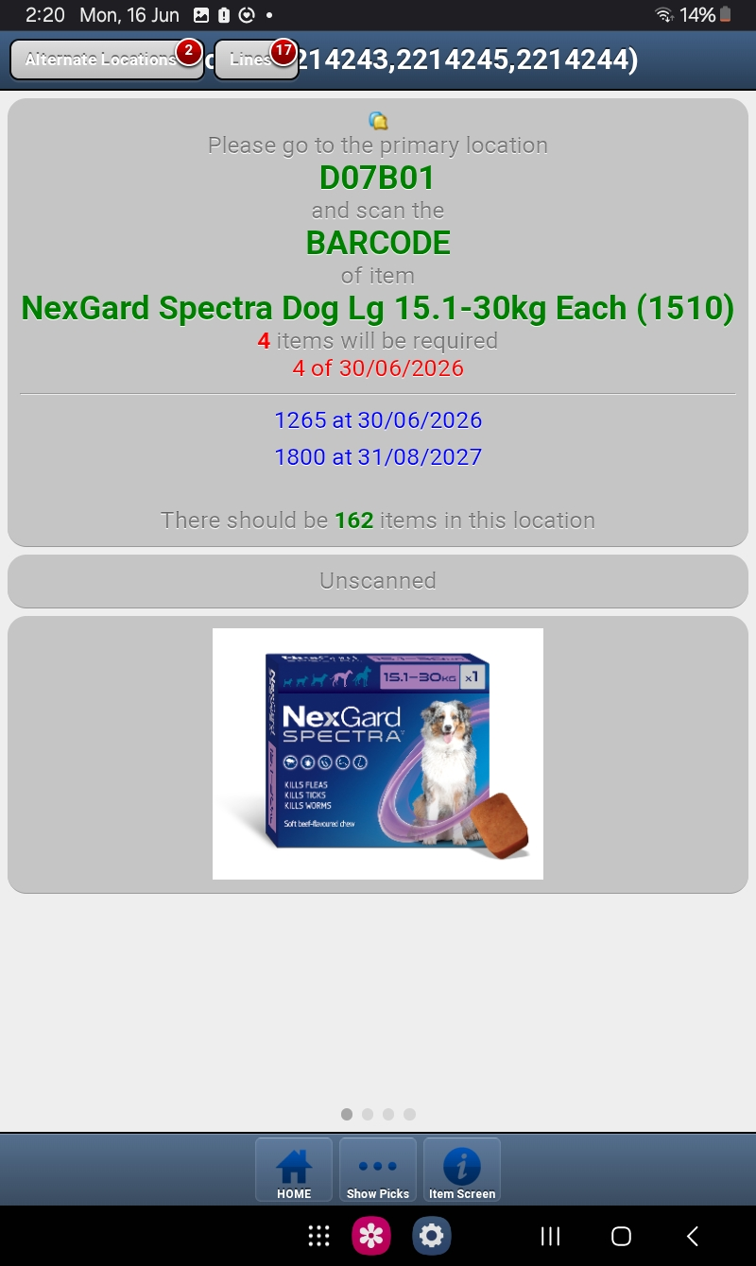**Location:** Below the instruction, the specific **Location** of the item you need to pick will be clearly stated.
* **Scanning Instruction:** This line will read: "**and scan the** [**BARCODE** or **LOCATION**] **of item**".
  + **Barcode Type:** This indicates whether you need to **scan the product's barcode** or **scan the location barcode** to confirm the pick.
* **Product Name:** The **{Item code or SKU}** **{Product name}** will be displayed so you know exactly what item you're looking for.
* **Quantity Required:** You'll see "**{amount} items will be required**," telling you the exact quantity needed for this specific line item.
* **Expiry Date Requirement:** This shows the required expiry date for the item: "**{amount} of {expiry date}**".
* **Available Expiry Dates (if applicable):** If there are multiple expiry dates for that product across the warehouse, a list of **quantities of items at different expiry dates** will be shown for your reference.
* **Expected Quantity in Location:** Phoenix will tell you: "**There should be {quantity} items in this location**," helping you verify stock levels before picking.
* **Scan Status Indicator:**
  + **Unscanned:** This will initially appear.
  + Turns **red** if you scan the wrong barcode.
  + Turns **green** if you scan the correct barcode, confirming the pick.
* **Item Image:** **A** **picture of the item** will be displayed to aid in visual identification, especially for similar products.

**Scanning and Quantity Confirmation:**

When you scan a product or location as prompted:

* **Barcode Scan (Product):**
  + **Single Product (Quantity 1):** If only one of the product is required, a red button spanning the top of the screen will appear, reading "**Next**." 
  + 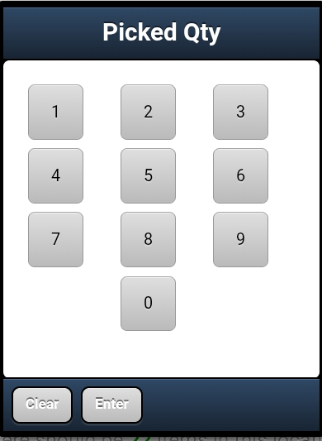**Multiple Products (Quantity > 1):** If you need more than one of the product, a pop-up box will appear with a field called "**Picked Qty**" and a numeric keypad. You only need to scan **one barcode** for the item, not each individual unit. Enter the exact **amount you have picked** using the num pad to confirm. Once the correct amount is entered, the "**Next**" button will appear at the top of the screen.
  + **Error:** If you scan the wrong product barcode, a pop-up will say "**Barcode does not match!**".
* **Location Scan:**
  + **Product Confirmation:** Regardless of the quantity, when you perform a **location scan**, a pop-up will appear asking: "**Are you sure this is in fact {product name}?**" You must select **"Yes"** to confirm it's the correct product.
  + **Quantity Confirmation:** After confirming the product, the process continues as with barcode scans: a pop-up box with "**Picked Qty**" and a numeric keypad will appear (for any quantity). Enter the amount picked, and the "**Next**" button will appear.

**Underpicking Procedures:**

You are **not able to over-pick** an item. However, you are able to **underpick** if necessary.

* A screenshot of a phone

  AI-generated content may be incorrect.**Underpicking Alert:** If you enter a quantity less than the amount required, a pop-up alert will appear:
* **Correcting Quantity (If "No"):** If you select **"No"**, you can re-enter the quantity by clicking into the white box at the top of the screen that says "**Confirmed Qty Picked {Current Qty}**." This will bring the numeric keypad back up.
* **Confirming Underpick (If "Yes"):** If you select **"Yes"** to confirm the underpick, a dropdown box for "**Reason**" will appear. You **must select a valid reason** for underpicking:
  + **Pick from Elsewhere:** (Used if you need to pick from multiple locations; specific procedures TBD).
  + **Expired Stock:** For stock that has passed its expiry date. (Typically used if it's the only stock left in the location).
  + **Expiry date not ideal:** If the clinic requires a minimum expiry date (e.g., 6 months minimum), and the available stock doesn't meet it.
  + **Internal error:** For inventory discrepancies or system errors.
  + **Not found:** When the item cannot be located by the picker.
  + **Stock damaged:** For items that are physically damaged and unsuitable for dispatch. (Typically used if it's the only stock left in the location).
* A screenshot of a computer

  AI-generated content may be incorrect.A screen shot of a computer

  AI-generated content may be incorrect.A close-up of a computer screen

  AI-generated content may be incorrect.**Supervisor Confirmation:** Any underpicking must be shown to a **supervisor for confirmation**.

### 1.4. Alternate Locations and Page Navigation (Within Picking Screen)

Your handheld device has multiple pages accessible by swiping left/right or by specific buttons.

* **Accessing Alternate Locations (Page 2):** In the top-left corner of the pick screen, you'll find the **"Alternate Locations"** button. A small number next to it indicates how many alternate locations exist for that item (it can be 0). Clicking this takes you to **Page 2**.
* **Page 2: Combination Page:** This page provides a wealth of information:
  + 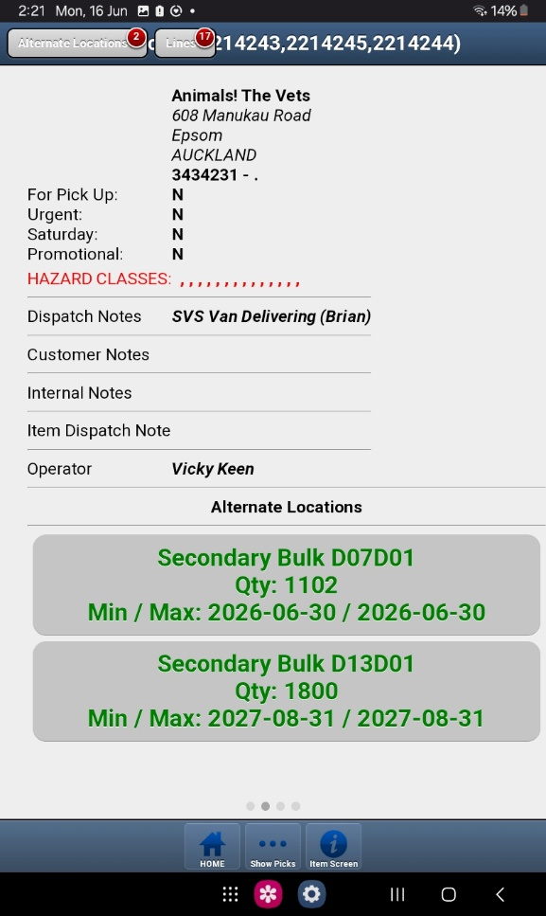Clinic Name
  + Clinic Address
  + SVS Invoice Number
  + "For Pick Up:" (Y/N)
  + "Urgent:" (Y/N)
  + "Saturday:" (Y/N)
  + "Promotional:" (Y/N)
  + Dispatch Notes
  + Customer Notes
  + Internal Notes
  + Item Dispatch Notes
  + Operator
  + **Alternate Locations List:** Below this information, all alternate locations for the item are listed.
* **Selecting an Alternate Location:** You can click on any of the listed alternate locations. A pop-up box will appear, asking: "**Would you like to override suggested pick?**" Select **"Yes"** to pick from the alternate location you selected.
* **Page 3: Expiry Batches:** Swiping right again will take you to **Page 3**, which is filled with expiry batch details. If you need to pick a specific date from one location, this is where you do it from.
* **Page 4: "Lines" Overview:** This page can be reached by swiping right from Page 3 or by clicking the "Lines" button (with the number of lines next to it) usually found near the "Alternate Locations" button. This page provides an overview of all products in the current order:
  + 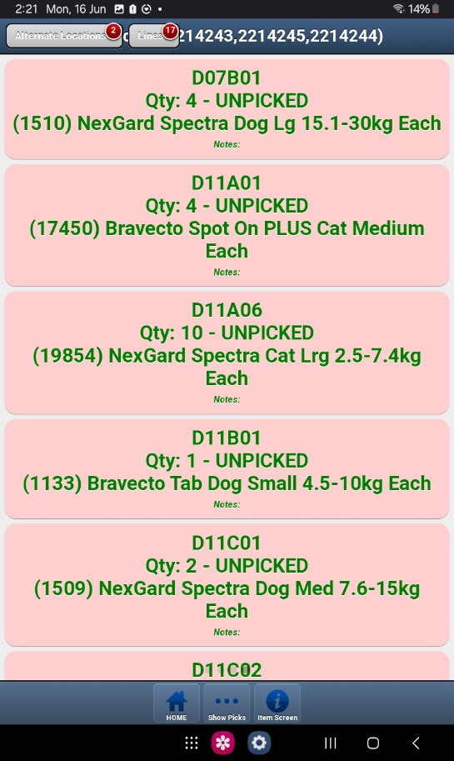**Item's Location:** The designated location for the item.
  + **Qty: {qty} - { "UNPICKED" or "PICKED"}:** Shows the quantity of the item and its current picking status.
  + **{Item Code} {Item Name}:** The unique code and name of the product.
  + **{Item Notes}:** Any specific notes related to that individual item.
  + **Picking Out of Order:** While orders are typically picked in an optimized aisle order (B, C, D, E, EB, EC, ED, EF, F, G, H, P, Q, R, S, T, W, V, X, Z), you can **click on any product on this "Lines" page to pick it "out of order"** if needed for efficiency or other reasons.

## 2. Order Picking Procedures

Accurate and efficient picking is crucial for customer satisfaction.

### 2.1. Best Practices for Picking Orders

**Focus on One Clinic:** To minimize errors and ensure accuracy, **always focus on picking orders for one clinic at a time.** Avoid mixing items or processes for different clinics.

**Open with Intent:** Only open an order on your handheld device if you **intend on picking it immediately**. Once an order is clicked into (opened for picking), it becomes **locked to your account** and cannot be unallocated from you.

* **Unallocation:** If an order has been allocated to you but you **haven't yet clicked into it** on the handheld, a supervisor can still unallocate it. However, once you click into the pick, it cannot be unallocated.

**Locating Products:** Every product in the warehouse has a designated location. Refer to Phoenix for the precise location of each item.

**Scanning:**

* **Barcode Scan:** For most items, you'll scan the product's barcode to confirm it's the correct item.
* **Location Scan:** Some items may require a location scan in Phoenix to confirm you're picking from the correct bin or shelf.

**Item Details:** Always verify the following against the Phoenix order:

* **Amount:** Ensure you pick the exact quantity specified.
* **Expiry Date:** Check the expiry date to ensure it meets our quality standards. Don't pick expired or near-expired products unless explicitly instructed.
* **Picture of the Item:** Use the item picture in Phoenix to visually confirm you have the correct product, especially for similar-looking items.

**Alternate Locations:** Be aware that some products may have alternate locations, such as **Bulk** storage or **secondary locations**. Phoenix will indicate if an alternate location should be used.

### 2.2. Warehouse Layout and Picking Order

Items are picked in alphabetical order by aisle to optimize efficiency. Understanding the location format will help you find items quickly:

* **B-H:** Large racking (mostly consistent layout with slight height differences).
  + A bar code with numbers and letters

    AI-generated content may be incorrect.**Location Example: B21A01**
    - **B:** Indicates the **Aisle** (e.g., B, C, D, etc.).
    - **21:** Indicates the **Block** within the shelving unit (See purple lines in photo). Blocks run from 5-41 on the right side and 6-42 on the left side.
    - **A:** Indicates the **Level** (up or down) within the block (See turquoise lines in photo).
    - A bar code with numbers

      AI-generated content may be incorrect.**01:** Indicates the **Slot** within that level and block. Slots can be A 01-03, B 01-08, C 01-08, D 01-08, E 01-02, F 01-02, H 01-02.
* **P-T:** Small shelves. Locations generally follow the format P001-P500 (and similarly for Q, R, S, T).
* **W:** Needle file cabinet. Locations generally follow the format W001-W200.
* **V:** Drug safe. Locations generally follow the format V001-V100.
* **X:** Chiller. Locations are similar to B-H, but are specific to X01-X08.
* A bar code with numbers

  AI-generated content may be incorrect.**Z:** Frozen and Miscellaneous
* **EB-EF:** Equipment

### 2.3. Underpicking an Order

If you're unable to pick the full quantity of an item, you must **underpick** in Phoenix and provide a valid reason. Common reasons include:

* **Not Found:** The item couldn't be located in its designated or alternate locations.
* **Damaged:** The item is visibly damaged and unsuitable for dispatch.
* **Internal Error:** An inventory discrepancy or system error.
* 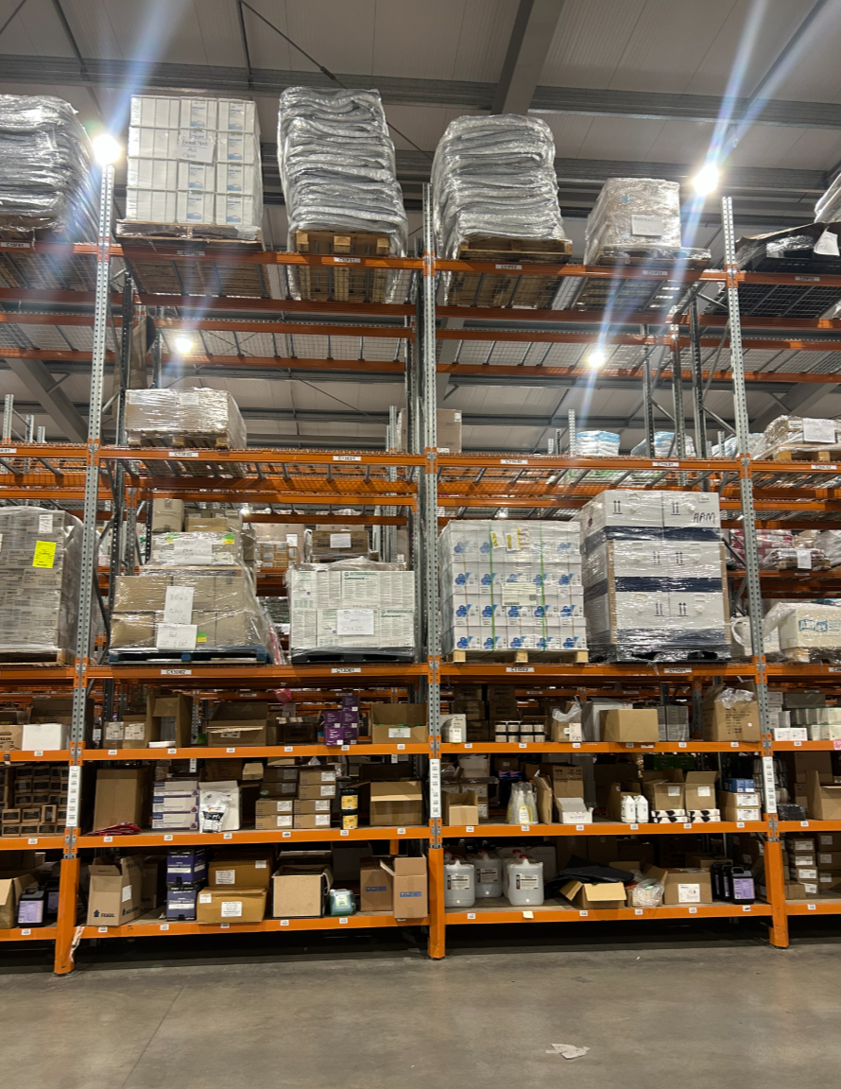**Expiry Date Not Ideal:** The expiry date doesn't meet our minimum requirements for dispatch.

## 3. Packing Procedures

Careful and appropriate packing ensures products arrive at their destination safely and in excellent condition.

### 3.1. General Packing Rules (Applies to all order types unless specified otherwise)

**Box Selection:** Choose an appropriate box size for the items being packed.

**Fragile and Small Items:**

* Small and fragile items are to be placed in a **box within a box** for enhanced protection.
* **Glass items** must be wrapped in bubble wrap.

**Liquids:** Pack liquids standing upright and apply "**This Way Up**" stickers to the box (unless specified otherwise for SVS Van deliveries).

**Special Stickers:**

* **Top Stow Stickers:** Apply to boxes that must remain upright and have nothing stacked on top of them.
* **Mixed Goods Stickers:** Use these stickers when you pack items into a box with a company logo (rather than a blank box) to indicate that the contents aren't limited to the brand on the box.

### 3.2. Carton Sizes and Volumes

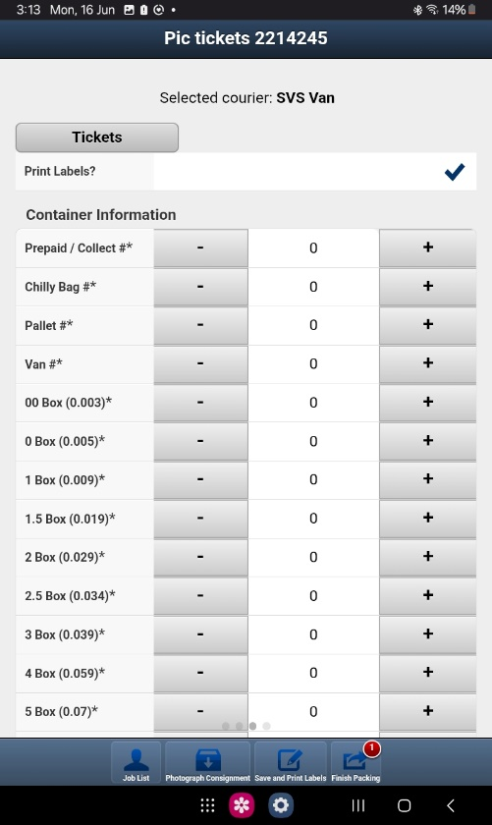The following table lists the standard carton sizes and their corresponding volumes:

|  |  |
| --- | --- |
| **Box Size** | **Box Volume (m3)** |
| 00 | 0.003 |
| 0 | 0.005 |
| 1 | 0.009 |
| 1.5 | 0.019 |
| 2 | 0.029 |
| 2.5 | 0.034 |
| 3 | 0.039 |
| 4 | 0.059 |
| PFS | 0.059 |

- PFS (Pet Food Shipper) is a large plastic bag for shipping large food bags.

### 3.3. "Packs" Menu Item

The "Packs" menu in Phoenix is where you finalize orders after they've been picked. It functions similarly to the "Picks" screen, showing completed jobs.

* 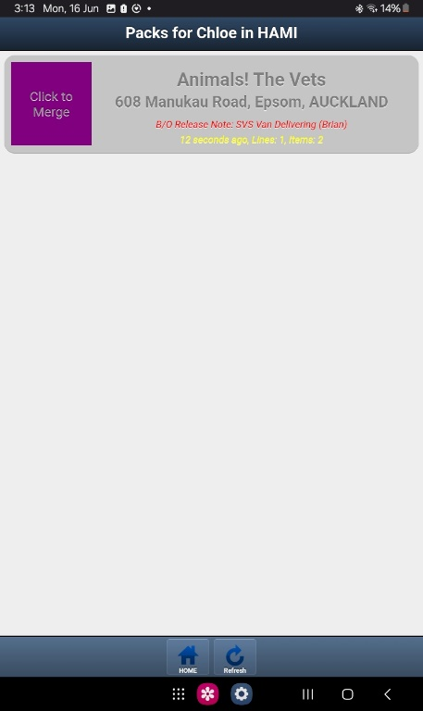**Overview:** The "Packs" screen will display all orders for which picking has been completed. The information presented for each order is the same as in the "Picks" screen (Clinic Name, Address, Lines, Items, Special Item Icons, etc.).
* **Time Display:** The time displayed will show **how long ago the order was completed (picked)**, rather than when it was allocated.
* **Merging:** You can **merge orders for the same clinic** on the "Packs" screen using the "**Click to merge**" button, following the same procedure and considerations as described for the "Picks" screen (Section 1.2).
  + **Note:** Once an order's picking is complete and it moves to the "Packs" stage, it **cannot be unallocated** from your account.

#### 3.3.1. "Packs" Screen - Page 1: Consignment Details

When you open an order from the "Packs" menu (or a merged group of orders), the first screen you'll see contains general consignment details:

* **No. : New Consignment:** This field is static and should never be changed.
* **Airport* : {airport list for NZ}:** This usually auto-populates. If it doesn't, guidance on determining the correct airport will be provided (TBD).
* **Carrier* : {Carrier}:** Select the appropriate carrier for the order. For Hamilton operations, the main carriers used are:
  + New Zealand Couriers (NZC)
  + NZ Post
  + Toll (Team Global Express / TGE)
  + SVS Van
* **2 Day Service* {tick box}:** Usage of this tick box is TBD.
* **"View products in pack" button:** Click this to see a detailed list of all products included in the current pack.
* **Default Carrier: {determined by finance team}:** This displays the carrier pre-selected by the finance team for the order.
* **Customer:** The customer's name.
* **Address:** The customer's delivery address.

#### 3.3.2. "Packs" Screen - Page 2: Notes and Order Numbers

Swiping to the second page provides important notes and order reference numbers:

* 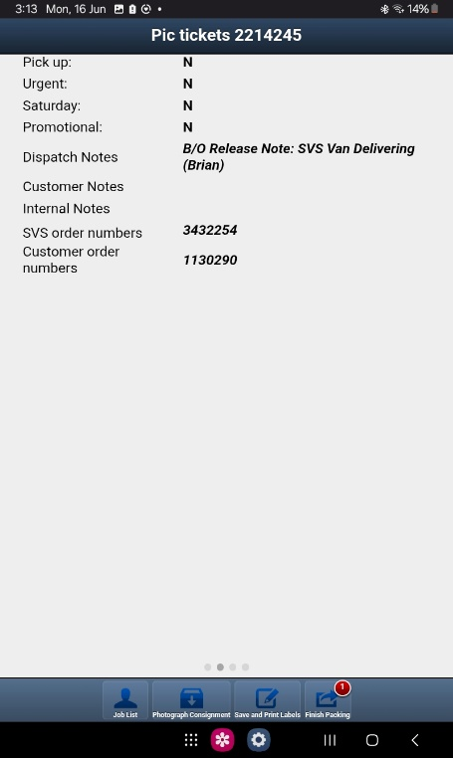**Pick up: (Y/N):** Indicates if the order is for customer pickup.
* **Urgent: (Y/N):** Flags the order as urgent.
* **Saturday: (Y/N):** Indicates if Saturday delivery is required.
* **Promotional: (Y/N):** Denotes if the order relates to a promotion.
* **Dispatch Notes:** Any special instructions for dispatch.
* **Customer Notes:** Notes from the customer regarding the order.
* **Internal Notes:** Internal SVS notes.
* **SVS Order numbers {SVS Invoice Number(s)}:** The SVS invoice number(s) for the order. If orders were merged, all relevant invoice numbers will be listed here.
* **Customer order numbers {Customer Order Number(s)}:** The customer's order number(s). If orders were merged, all relevant customer order numbers will be listed.

#### 3.3.3. "Packs" Screen - Page 3: Carton Select Page

Swiping to the third page is where you select the cartons and apply necessary tickets/labels.

* **"Selected courier: {selected courier}"**
* **"Tickets" button:** This opens a text box where you will **scan in DG (Dangerous Goods) or Rural NZC courier tickets**.
* **"Print Labels?" {tick box}:** This box **must always be ticked** to ensure shipping labels are generated.
* **Container information:** This section allows you to select the types and quantities of containers used.
* **Container Types (with + and - buttons for quantity):**
  + **Prepaid / Collect #\***: This option can only be selected once per consignment. If selected, **no shipping labels will be printed**; only the invoice is needed (e.g., for customer pickup orders).
  + **Chilly Bag:** Selecting this option doesn't print a label but is used internally to track the number of chilly bags dispatched.
  + **Pallet:** Only used for **Toll (Team Global Express / TGE)** carrier orders.
  + **Van:** This is a **legacy option and is no longer used**.
  + **Box Sizes:** Standard carton sizes are available for selection:
    - 00, 0, 1, 1.5, 2, 2.5, 3, 4
    - Less frequently used sizes: 5, 8
    - **PFS:** Pet Food Shipper bag.
  + 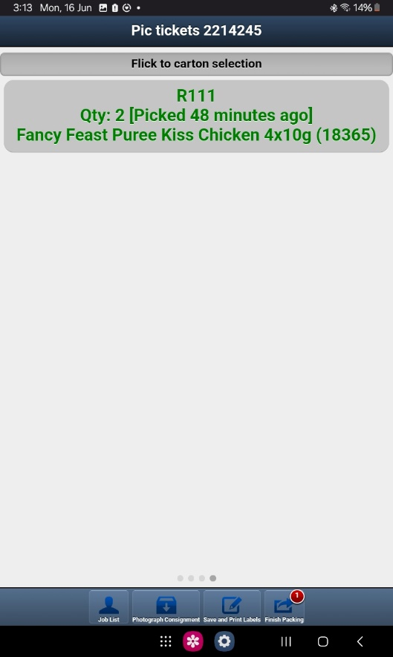**E bags (E11, E20, E40, E50, E60):** These are **not used** for packing.

#### 3.3.4. "Packs" Screen - Page 4: Packed Lines Overview

Swiping to the fourth page provides an overview of all products included in the packed consignment, similar to the "Lines" page in the picking screen. It will show:

* **Item's Location:** The warehouse location from which the item was picked.
* **Qty:** The quantity of the item packed.
* **Item Name:** The name of the product.
* **Item Code:** The unique code for the product.

#### 3.3.5. Finalizing the Pack - Bottom Screen Buttons

* **"Job List":** Takes you back to the main "Packs" menu.
* **"Photograph Consignment":** This button is **never used** by general dispatch workers.
* **"Save and Print Labels":**
  + **Crucial Step:** This button prints the shipping labels for the order.
  + **Always press this BEFORE pressing "Finish Packing."**
  + **Once you have pressed the button this message will show:**

* **"Finish Packing":**
  + This button completes the job in Phoenix and triggers the printing of all necessary paperwork that goes with the order (e.g., invoices).
  + **Requirement:** You cannot "Finish Packing" if you haven't selected at least one carton size or the "Prepaid / Collect" option.
  + **Warning:** The system *will* allow you to "Finish Packing" even if you haven't pressed "Save and Print Labels." Always ensure labels are printed first.
  + **Reprinting Labels:** If labels weren't printed or are needed again in the future, they can be reprinted from the computer (not the handheld device).

## 4. Order Types and Specific Procedures

We handle four primary order types, each with its own specific packing and documentation requirements.

### 4.1. NZC (New Zealand Couriers) Orders

NZC orders are our standard courier deliveries and have specific rules for weight, dangerous goods, and chilled items.

#### 4.1.1. General NZC Requirements

**Weight Limit:** Individual boxes must be under **25kg**.

**Liquids:** Liquids must be packed standing upright and receive a "**This Way Up**" sticker.

**Rural Addresses:** If Phoenix prompts with a "Rural Delivery" notification, you must attach **one Rural NZC courier ticket per carton** for that order.

#### 4.1.2. Dangerous Goods (DG) for NZC

**Documentation:** When DG paperwork prints with the invoice(s):

* You must write the **weight of the product** on the paper.
* You must write the **volume of the box** it's packed in.
* Write "**DGLQ**" at the top of the paper if applicable (see DGLQ rules below).
* **Sign your name** at the bottom of the paper.
* **Copies for Dispatch:**
  1. **Photocopy the filled-out and signed DG form twice.**
  2. **Fold and tape these two copies securely to the outside of the box containing the DG.**
  3. **Place one additional copy on the clipboard for the NZC driver to take.**

**Packing:**

* DG items **must be packed in their own boxes**, separate from non-DG items.
* Only **same DG classes can be packed together** in a single box.

**Stickers:**

* Apply **one class sticker** to the box (e.g., Class 3, Class 9).
* **Exception:** Class 6.1 Dangerous Goods only receive a DGLQ sticker, not a class sticker.
* **DGLQ Sticker:** Apply a **DGLQ sticker** if the DG is **Class 2.1 or Class 3 AND is under 4 litres**.

**Courier Ticket:** A specific **NZC DG courier ticket** must be scanned into Phoenix for each box containing Dangerous Goods in the packing screen. 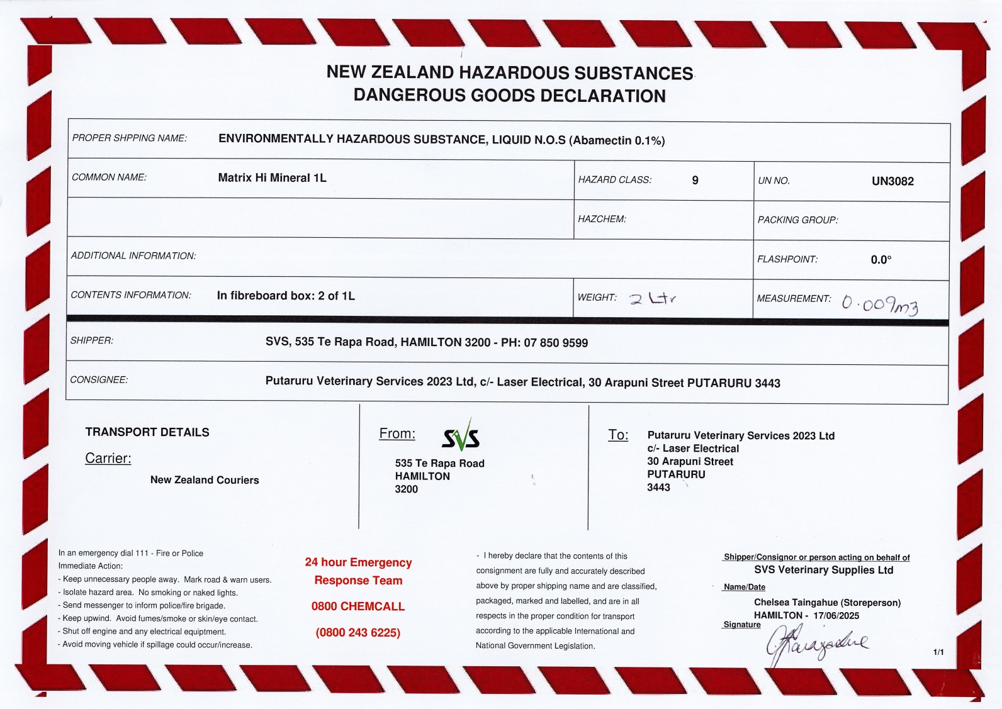

Whether it’s a DGLQ this is where you write it

#### 4.1.3. Chilled Items for NZC

**Packing:**

* Chilled items go into a **chilly bag** or a **Styrofoam box** if there's a large quantity.
* Chilled items need to go in their **own box** if able.

**Ice Packs:**

* **All ice used must be bagged** to prevent water damage to products when thawing.
* **Chilly Bags:** Use a minimum of **two bagged ice packs**.
* **Styrofoam Boxes:** Use more bagged ice packs as appropriate to maintain temperature for the duration of transit.

**Stickers:**

* Apply a **refrigerated sticker** to the box.
* Apply the **orange SVS chilled sticker** that states: "If not received within 24 hours of the departure date and time, then then return to SVS."

#### 4.1.4. Carton Sizes for NZC

All carton sizes listed in Section 3.2 are applicable for NZC orders.

### 4.2. SVS Van Delivery Orders

These orders are delivered directly by our SVS vans and have simplified DG and chilled item procedures.

#### 4.2.1. General SVS Van Requirements

**Dangerous Goods (DG):**

* **DG paperwork is discarded.**
* **No DG stickers** or **DG courier tickets** go on boxes. This is strictly for NZC courier deliveries only.

**Weight Limit:** Maximum weight limit is **15kg per box or PFS**.

#### 4.2.2. Chilled Items for SVS Vans

**Separate Packing:** All chilled items are packed separately.

**Stickers:** Only a **refrigerated sticker** is applied to the box. The orange SVS chilled sticker is *not* used for SVS Van deliveries.

**Icing Responsibility:** Nightshift staff **don't ice** the bags. Day staff are responsible for icing the bags in the morning before dispatch.

* **All ice used must be bagged** to prevent water damage to products when thawing.

#### 4.2.3. Carton Sizes and Van Routes

The following carton sizes can be used for SVS Van Delivery:

|  |  |
| --- | --- |
| **Box Size** | **Box Volume (m3)** |
| 00 | 0.003 |
| 0 | 0.005 |
| 1 | 0.009 |
| 1.5 | 0.019 |
| 2 | 0.029 |
| 2.5 | 0.034 |
| 3 | 0.039 |
| PFS | 0.059 |

As of 2025, there are four SVS van routes:

* North Auckland
* South Auckland
* Central / West Auckland
* Local Van (Hamilton and Cambridge)

**Important Note on Van Delivery Eligibility:** **Not all Auckland or local clinics receive SVS Van delivery.** The clinics eligible for SVS Van delivery change quite regularly. To determine if an order is for SVS Van Delivery, you **must check the dispatch notes for "SVS Van Delivering" or "SVS Local delivering."** Additionally, lists of the specific clinics for each van are available above their respective pallets. You must ensure the order goes on the correct pallet for the correct van to avoid delaying the night shift's van loading process.

#### 4.2.4. Van Loading Procedures

At 9 PM each night, the night crew loads the vans with the orders packed that day for delivery the following morning (e.g., load Monday night, deliver Tuesday).

* Chilled boxes for van delivery are left on the floor in the chiller.
* Chilled boxes for NZC delivery are placed on the cage trolley in the middle of the chiller.

### 4.3. EDI / Toll Orders (Electronic Data Interchange)

EDI orders are generated through electronic communication with our key retail partners. These orders can be small enough for NZC or large enough for palletized delivery via Toll/TGE.

**Crucial Note:** Unless explicitly instructed by a supervisor or in order notes, **ALL EDI Flea and food orders DON'T get merged.**

#### 4.3.1. EDI Order Types

**Flea Treatment Orders:** Small enough to be shipped via NZC.

**Small Food Orders:** Small enough to be shipped via NZC.

**Large Food Orders:** Go on Toll/TGE (palletized).

#### 4.3.2. Customer-Specific EDI Guidelines

#### Animates

**SSCC Labels:** SSCC labels for Animates orders print from the **SATO printer**.

* For **all Animates clinics (except Botany Downs)**: When selecting a box size in Phoenix, the list of all products in the order will appear. Select your first box size, then click "**Pack All**." Then, select the "**Select another box**" button. When you select additional boxes, no products will show up on the list; this is expected and correct.
* For **Botany Downs Animates clinics:**
  + They require **one SSCC label per carton**.
  + When selecting box sizes in Phoenix, you **don't click "Pack All."** Instead, you must **manually specify which products go into each box** by selecting them from the list. Remember which products are physically packed into the box size you're currently working with.

**Dated Stock:** Animates dated stock is **always pre-approved**. If Phoenix shows an "expiry is bad" warning, **pick the item anyway**.

**Pallet Height Limit:** 1.5-meter height limit for pallets.

#### Pet Stock

**PFS Bags:** **No PFS bags** are to be used for Pet Stock orders; only boxes (if shipping via NZC).

**Dated Stock:** If a "Dated stock" warning shows up, **check bulk locations** for items with better expiry dates. If no suitable dates are found, then **underpick as "expiry date not Ideal."**

**Pallet Height Limit:** 1.5-meter height limit for pallets.

#### Pet.co

**Partial Trays of Cans:** **No partial trays of cans**. If your order includes less than a full tray, **underpick until only full trays remain.**

**PFS Bags:** **No PFS bags** are to be used for Pet.co orders; only boxes (if shipping via NZC).

**Dated Stock:** If a "Dated stock" warning shows up, **check bulk locations** for items with better expiry dates. If no suitable dates are found, then **underpick as "expiry date not Ideal."**

**Pallet Height Limit:** 1.4-meter pallet height limit.

#### Pet Direct

**Dated Stock:** If a "Dated stock" warning shows up, **check bulk locations** for items with better expiry dates. If no suitable dates are found, then **underpick as "expiry date not Ideal."**

**Collection Booking:** **ALWAYS see a Supervisor before booking collection.**

**Pallet Height Limit:** 1.4-meter height limit.

### 4.4. Toll / TGE (Team Global Express) Orders (Palletized)

Toll, now known as Team Global Express (TGE), handles our palletized freight.

#### 4.4.1. General Toll/TGE Guidelines

**Pallet Stacking:** Pallets must be stacked and **hand-wrapped securely**.

**Non-EDI Pallet Limits:** If the order is **not an EDI clinic** mentioned above:

* **Weight Limit:** 800kg per pallet.
* **Height Limit:** 1.6m per pallet.

**Information for Booking:** When entering information into the Toll portal or Phoenix for creating an order, you'll need:

* The **volume of each pallet**.
* The **count of pallets**.
* The **total weight of all pallets**.

#### 4.4.2. Using the Toll Carrier in Phoenix

**When NOT to use the Toll Carrier (requires manual booking via Toll Portal):**

1. **Specific Delivery Date:** If you need a specific delivery date (e.g., "Deliver next week").
2. **Dangerous Goods:** If you have Dangerous Goods on the order.
3. **Split Delivery:** If you have a split delivery (e.g., 1 pallet on Toll and 1 box going on NZC).
4. **Special Delivery Requirements:** If you have special delivery requirements (e.g., "Truck with tail lift").

**When it's OKAY to use the Toll Carrier in Phoenix:**

* When you have an order that consists **only of pallet(s)** and is getting **picked up ASAP** and **has no special requirements**.

*If you can't use the Toll Carrier in Phoenix, you must go to the Toll portal and enter everything manually and use NZC as the carrier and select Prepaid / Collect.* (Further instructions on manual portal entry will be provided separately).

#### 4.4.3. Dangerous Goods (DG) for Toll/TGE

**Procedures:** Dangerous Goods for Toll/TGE orders are handled the **same way as for NZC orders** regarding paperwork, packing, and stickers (class sticker, DGLQ sticker if applicable, same classes packed together).

**Documentation Copies:**

* **Photocopy the filled-out and signed DG form.**
* **Securely tape copies of this form to all four sides and the top of the pallet containing the DG.** This means you'll need **five copies total per pallet**.

**Courier Ticket:** **They don't get the scanned-in courier ticket** that NZC DG orders receive.

### 4.5. Dropships

## 5. Stock Count

Notes: 